Notes:
In priority (priority 1 has higher priority than priority 5)
If two processes have the same priority, the one that arrived first (FCFS) is selected. If they arrive at the same time, the one entered first in the input list is selected."

Test scenarios

Scenario A:
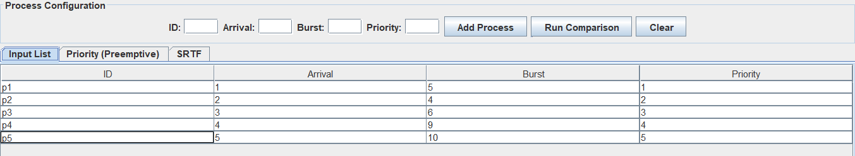
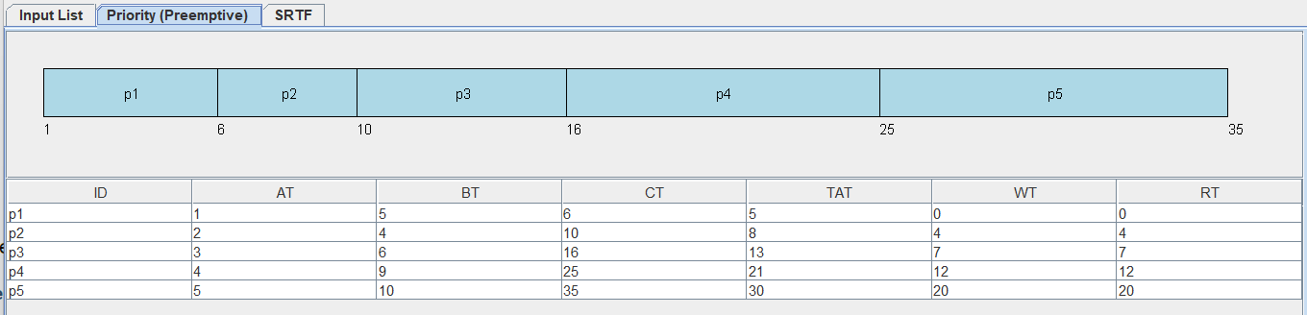
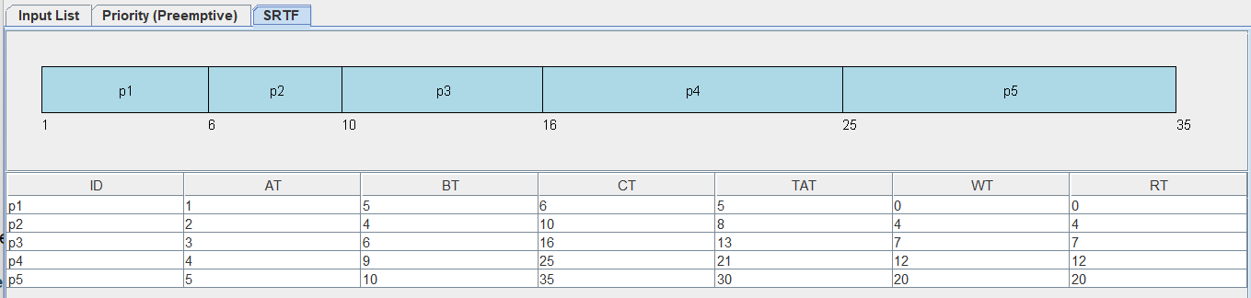
Scenario B:
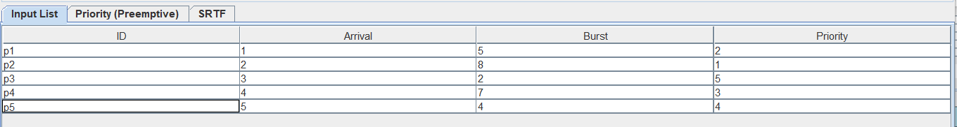
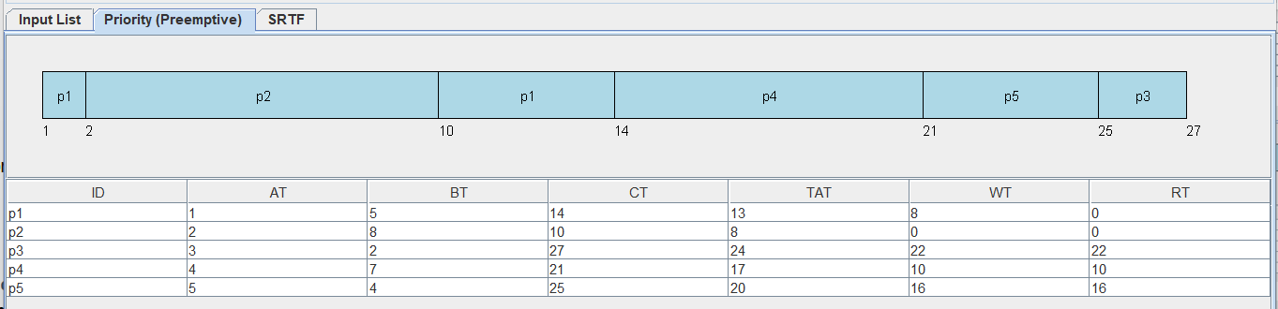
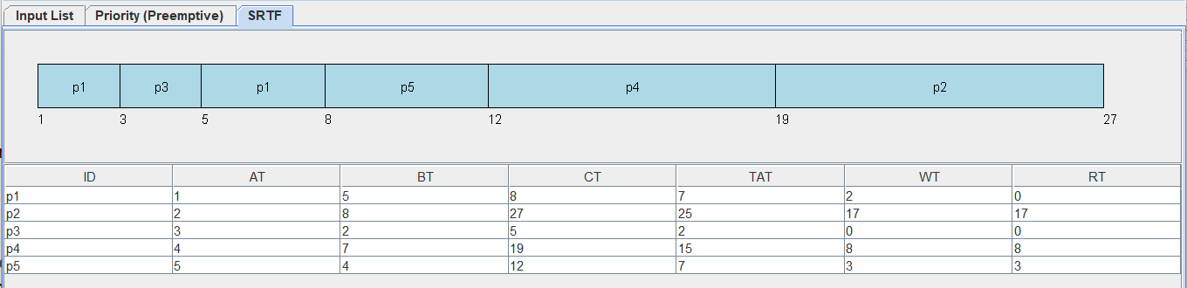
Scenario C:
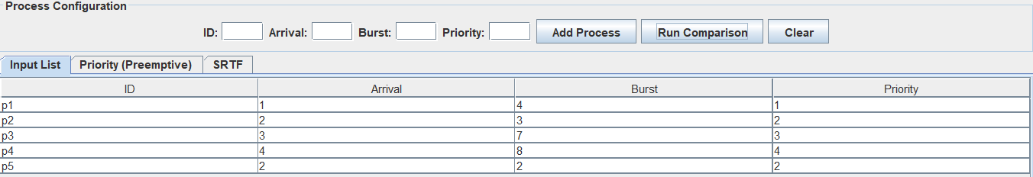
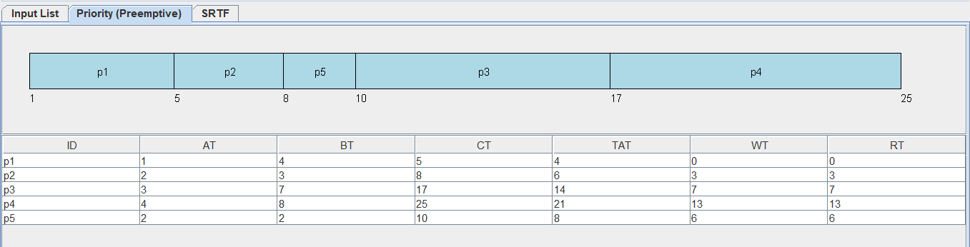
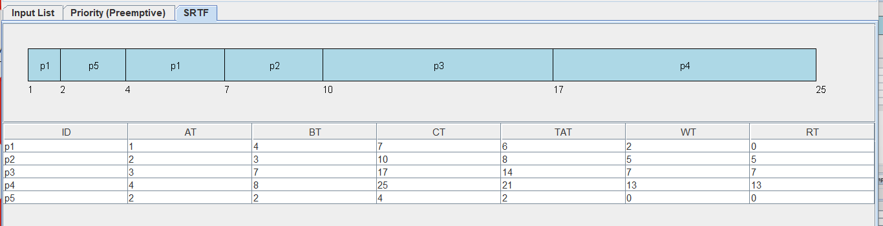
Scenario D:
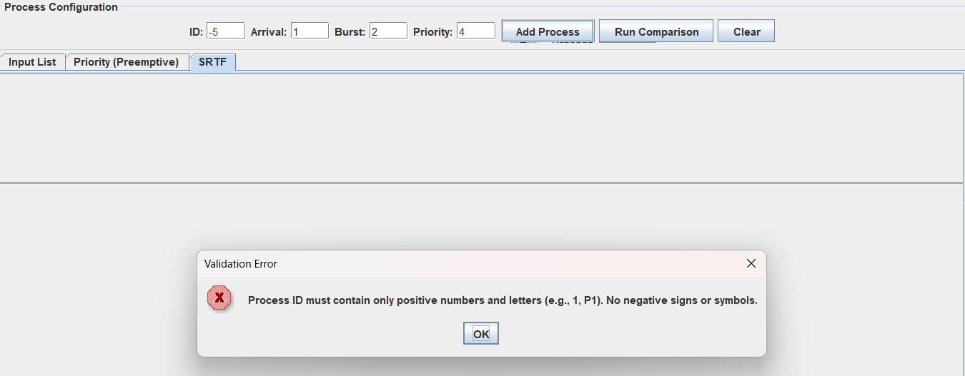
Analysis Questions:
1.Which algorithm produced the lower average waiting time?
In scenario A AWT (Priority) = 8.6
In scenario A AWT (SRTF) = 8.6
In scenario B AWT (Priority) = 11.2
In scenario B AWT (SRTF) = 6
In scenario C AWT (Priority) = 5.8
In scenario C AWT (SRTF) = 5.4
So, depending on the results the SRTF is produced the lower AWT.

2.Which algorithm produced the lower average response time?
In scenario A ART (Priority) = 8.6
In scenario A ART (SRTF) = 8.6
In scenario B ART (Priority) = 9.6
In scenario B ART (SRTF) = 5.6
In scenario C ART (Priority) = 5.8
In scenario C ART (SRTF) = 5
So, depending on the results the SRTF is produced the lower ART.
3.Did priority values improve treatment of urgent processes?
Yes, of course
4.Did SRTF favor short jobs more aggressively?
Yes, it interrupts all the long jobs to finish the shorter ones.
5.Which algorithm would you recommend for the tested workload, and why?
I recommend SRTF because it gives better AWT and ART at our test cases A,B and C
Required Conclusion:
1.State which algorithm performed better on the selected datasets.
Answer SRTF is better
2.State which metrics were better under each algorithm.
Answer In scenario A its metrices give the same in the 2 algorithm, but in scenario B and C its metrices gives better result in AWT and ART at STRF Algorithm.
3.Identify the main trade-off observed.
Answer If you choose the priority algorithm, you will finish all the urgent processes first, but lower priority will wait a lot. On the other hand, if you choose the SRTF algorithm, you will finish all the shortest jobs first
But the urgent ones will wait a little bit longer to get done.
4.State which algorithm appeared fairer in practice.
Answer Neither algorithm is fair because in SRTF long processes will wait a lot if all the incoming processes has shorter jobs, and also priority is unfair because low priority will wait a lot if all the incoming processes has higher priority.

